Zma Wār
Software Design Document
Version 1.0
Design baseline: SRS Version 1.2
“Zma Wār” means “my turn” in Pashto.

Document Control
Item | Details
Document | Software Design Document (SDD)
System | Zma Wār appointment management system
SDD version | 1.0
Requirement’s baseline | Zma Wār Software Requirements Specification, Version 1.2
SRS publication date | 26 October 2026
System scope | Initial version for one fictional hospital

Contents
- 1. Introduction
- 2. Design Overview
- 3. System Architecture
- 4. Module Design
- 5. Database Design
- 6. User Interface Design
- 7. Main Process Designs
- 8. Security Design
- 9. Non-Functional Design
- 10. Deployment Design
- 11. Requirements Traceability
- 12. Design Decisions and Implementation Notes

1. Introduction

1.1 Purpose
This Software Design Document describes the proposed structure and behavior of Zma Wār. It translates the requirements in SRS Version 1.2 into a practical design for the initial implementation. It is intended to guide implementation, database creation, interface development, and testing.

1.2 Scope
Zma Wār is a browser-based appointment management system for one fictional hospital. Users can create accounts, verify their email addresses, view available appointment slots, reserve slots, manage their account and reservations, and receive email notifications. The administrator can manage reservations and configure system reminder settings.
Multi-organization support and a SaaS administration model are explicitly outside the current scope.

1.3 Design Basis
The design uses the supplied SRS Version 1.2 and the provided activity diagram and ER diagram. Where a technology or implementation detail is not specified in the SRS, this document describes a technology-neutral design recommendation rather than a confirmed requirement.

1.4 Terms
Term | Meaning in this document
Slot | A defined appointment period with a start and end time.
Reservation | A user's booking of an available appointment slot.
Active reservation | A reservation that has not been cancelled or deleted.
Lead time | The amount of time before an appointment when a reminder should be sent.
Administrator | The project owner with access to administrative functions.

2. Design Overview

2.1 Main Actors
Actor | Responsibilities
User | Register and log in; verify email; view available slots; reserve slots; manage account information; cancel own reservations; configure reminder lead time as stated in the SRS.
Administrator | Log in to the administrative panel; manage reservations; create reservations for users; cancel reservations; configure reminder lead time.
Email delivery service | Deliver verification, reminder, and administrator-cancellation emails. This is an external dependency.

2.2 Core Design Principles
- Keep the initial system as one web application for one fictional hospital.
- Separate presentation, application/business rules, and data access responsibilities.
- Validate important reservation rules on the server, not only in the browser.
- Treat the database as the authoritative source for slot availability and reservation state.
- Keep email delivery separate from the main reservation operation so email-service failures can be handled without silently corrupting reservation data.
- Avoid adding functionality that is not present in the approved SRS.

2.3 High-Level Data Flow
A browser sends a request to the web application. The application validates the request, checks the user's permissions and reservation rules, reads or updates the database, and returns a page or result. When an email is required, the application asks an email delivery service to send it. Scheduled reminder processing checks upcoming active reservations and sends reminders according to the configured lead time.

3. System Architecture

3.1 Proposed Architecture
Zma Wār will be implemented as a Next.js and TypeScript with React.js web application with a MySQL relational database. The application will be containerized with Docker and hosted on a cloud server. A three-layer structure is recommended to separate the presentation, application/business rules, and data-access responsibilities. REST APIs may be introduced selectively if they provide a clear benefit; they are optional and are not required for every operation.
Layer / component | Main responsibility
Presentation layer | Browser pages and forms for public slot viewing, registration/login, reservation actions, account management, and the administrator panel.
Application layer | Implements account workflows, email verification, slot search, reservation creation/cancellation, reservation limits, reminder settings, and authorization checks.
Data access layer | Runs parameterized database operations and maps stored users, appointment slots, and administrator data to application objects.
Relational database | Stores accounts, appointment slots/reservations, administrator credentials, and relevant reminder settings.
Email adapter | Sends verification emails, appointment reminders, and cancellation notifications through a configured provider.
Reminder scheduler | Runs periodically, identifies due reminders, and requests delivery through the email adapter.

3.2 Component Interaction
- The Next.js and TypeScript presentation/controller layer does not write directly to MySQL without going through the application's data-access logic.
- The Next.js and TypeScript application layer verifies identity and permission before performing protected actions.
- Reservation operations check slot availability and the user's active-reservation limit within a database transaction.
- The email adapter is called after the relevant state change has been safely stored, or through a durable queued job if the implementation uses one.
- The reminder scheduler must avoid repeatedly sending the same reminder; the design should record whether a reminder has already been sent.

3.3 Architecture Diagram
The following logical view summarizes the proposed components.
External / client | Application components | Storage / external service
User browser | Presentation pages → Authentication and authorization
Administrator browser | Admin pages → Reservation and account services | Relational database
 | Slot availability and reservation service → Reminder service | Email delivery provider
 | Email verification and notification service

This table is a logical component view, not a network topology. A graphical architecture diagram can be added later if required by the project submission.

4. Module Design

4.1 Account and Authentication Module
- Register a new user account and store the account information.
- Send an email verification link or button to the supplied email address.
- Allow existing users to log in.
- Allow users to update account information.
- Restrict account-management actions to the authenticated account owner.

4.2 Appointment Slot Module
- Retrieve appointment slots and display them in a table.
- Show whether each slot is available or reserved.
- Support the separate future-booking flow for available slots within the next month.
- Use the database state to determine availability; do not rely on a browser's potentially stale display.

4.3 Reservation Module
- Accept a request to reserve an available slot.
- Check that the slot exists, is in the permitted booking window where applicable, and is not already reserved.
- Check the SRS limit of no more than two active reservations per user.
- Save the reservation and update slot availability as one atomic operation.
- Allow users to cancel their own reservations.
- Allow the administrator to create a reservation on behalf of a user and delete a reservation.
- Make a cancelled/deleted slot available again, provided no other active reservation occupies it.

4.4 Reminder Configuration and Scheduler
- Use a default reminder lead time of 30 minutes, while allowing each user to configure the lead time for their own reminders.
- Allow each user to configure the lead time for their own reminders, using 30 minutes as the default.
- Periodically find active reservations whose reminder time is due.
- Send reminder emails and record successful delivery attempts so the same reminder is not repeatedly sent.
- Handle the case where a reservation has been cancelled before its reminder becomes due.

4.5 Email Verification and Notification Module
- Send account-verification messages during registration.
- Send appointment reminders before the appointment time.
- When an administrator cancels a reservation, email the affected user and invite them to choose another available slot.
- Keep email credentials and provider configuration out of source code.
- Handle provider failures with logging and retry behavior appropriate to the chosen email service.

4.6 Administrator Module
- Provide an administrator sign-in and protected administrative panel.
- Allow the administrator to manage reservations and reminder settings.
- Allow the administrator to create a reservation for a user.
- Allow the administrator to delete a reservation and trigger the cancellation email.
- Reject administrative requests from ordinary user accounts.

5. Database Design

5.1 Supplied ER Diagram
The supplied ER diagram contains the entities user, appointments, and admin. It models a user as reserving appointments and an administrator as managing appointments.
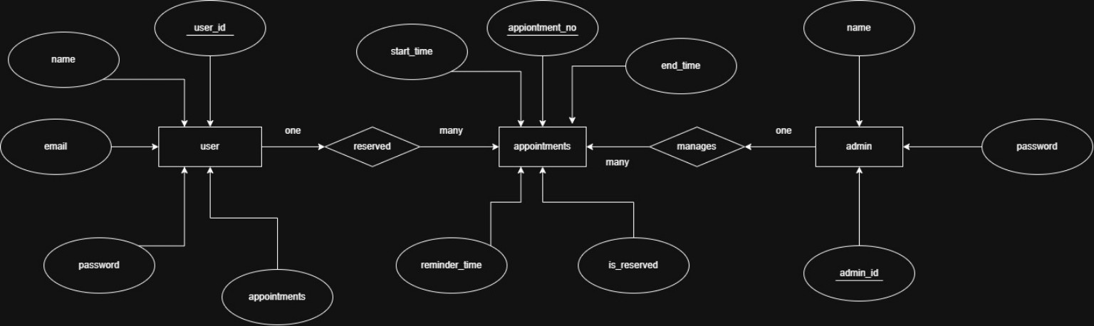
Figure 1. ER diagram.

5.2 Entities and Attributes
Entity | Attributes shown in supplied ER diagram | Design interpretation
user | user_id (key), name, email, password, appointments | Stores user identity and login information. The appointments attribute is better represented by the relationship to appointment records rather than as a single scalar field.
appointments | appointment_no (key), start_time, end_time, reminder_time, is_reserved | Represents appointment time slots and reservation-related state. The design must define whether reminder_time is per reservation or a shared setting.
admin | admin_id (key), name, password | Stores the administrator account. Administrator access must be protected separately from ordinary user permissions.

5.3 Relationship Design
Relationship | Intended cardinality | Implementation note
User reserves appointments | One user can have many appointment records; each reservation belongs to one user. | Store a user_id foreign key on each reservation record. The two-active-reservation limit must be checked by application logic and transaction-safe database operations.
Administrator manages appointments | One administrator can manage many appointment records. | The administrator's management actions are permissions/actions; a direct admin_id on every appointment may be unnecessary unless an audit trail is required.

5.4 Recommended Logical Schema
The following is a logical recommendation, not a claim that the supplied ER diagram already defines every field. Names and data types can be adapted to the selected database.
Table | Suggested fields | Purpose / constraints
users | user_id (PK), name, email (unique), password_hash, email_verified, created_at, updated_at | Account identity. Store a password hash, never a plaintext password.
appointments | appointment_no (PK), start_time, end_time, is_reserved | Defines available time slots. start_time must precede end_time.
reservations | reservation_id (PK), user_id (FK), appointment_no (FK, unique for active reservation logic), status, reminder_lead_minutes, reminder_sent_at, created_at, cancelled_at | Connects a user to a slot and tracks active/cancelled status. If the implementation stores reservations directly in appointments, preserve equivalent constraints.
admin | admin_id (PK), name, email or username (unique), password_hash | Protected administrator identity.
system_settings (optional) | setting_key (PK), setting_value | May store administrator-configured defaults such as the default reminder lead time.

The supplied ER diagram uses appointment_no as the appointment identifier. The suggested reservation table separates the slot from the act of reserving it, which makes cancellations and reservation history easier to represent. This is a proposed refinement to the logical data model, not a change to the SRS scope.

5.5 Data Integrity Rules
- Primary keys uniquely identify records.
- A reservation must reference an existing user and an existing appointment slot.
- A slot cannot have more than one active reservation.
- A user cannot exceed two active reservations.
- A cancelled reservation no longer counts toward the active-reservation limit.
- Email addresses used for account identity should be unique.
- Passwords must be stored as salted hashes using a suitable password-hashing function.
- Date/time comparisons must use a consistent timezone strategy.

6. User Interface Design
The SRS requires a simple, clear interface and appointment slots displayed in a table. The pages below are a proposed minimal screen set to support the stated requirements.
Page / view | Main elements and behavior
Appointment slots | Table of slot date, start time, end time, and status; reserve action for available slots; separate future-booking option.
Registration | Name and email fields, password fields, validation feedback, and confirmation that a verification email was sent.
Login | Account identifier and password; clear error messages that do not reveal sensitive account details.
User dashboard | User's active reservations, cancellation actions, account update option, and reminder lead-time control where enabled.
Reservation result | Confirmation that the reservation succeeded or explanation that the slot is no longer available or the reservation limit has been reached.
Administrator login | Separate or role-protected sign-in route for the administrator.
Administrator panel | Reservation list, create-reservation action, cancel/delete action, and reminder-setting control.
Email messages | Verification link, reminder details, or cancellation notice with a prompt to choose another slot.

6.1 Low-Bandwidth and Usability Considerations
- Keep pages lightweight and avoid unnecessary large images or scripts.
- Use readable labels, concise messages, and forms that work on common screen sizes.
- Provide clear status text in addition to color so availability is not communicated by color alone.
- Validate forms on the server and provide understandable correction messages.
- Avoid reloading or fetching more data than needed for the current view.

7. Main Process Designs

7.1 Supplied Activity Diagram
The activity diagram supplied by the project author shows users viewing available slots, registering or signing in, reserving a slot from the slot list or dashboard, and an administrator signing in. It also shows users managing account information and reservations.
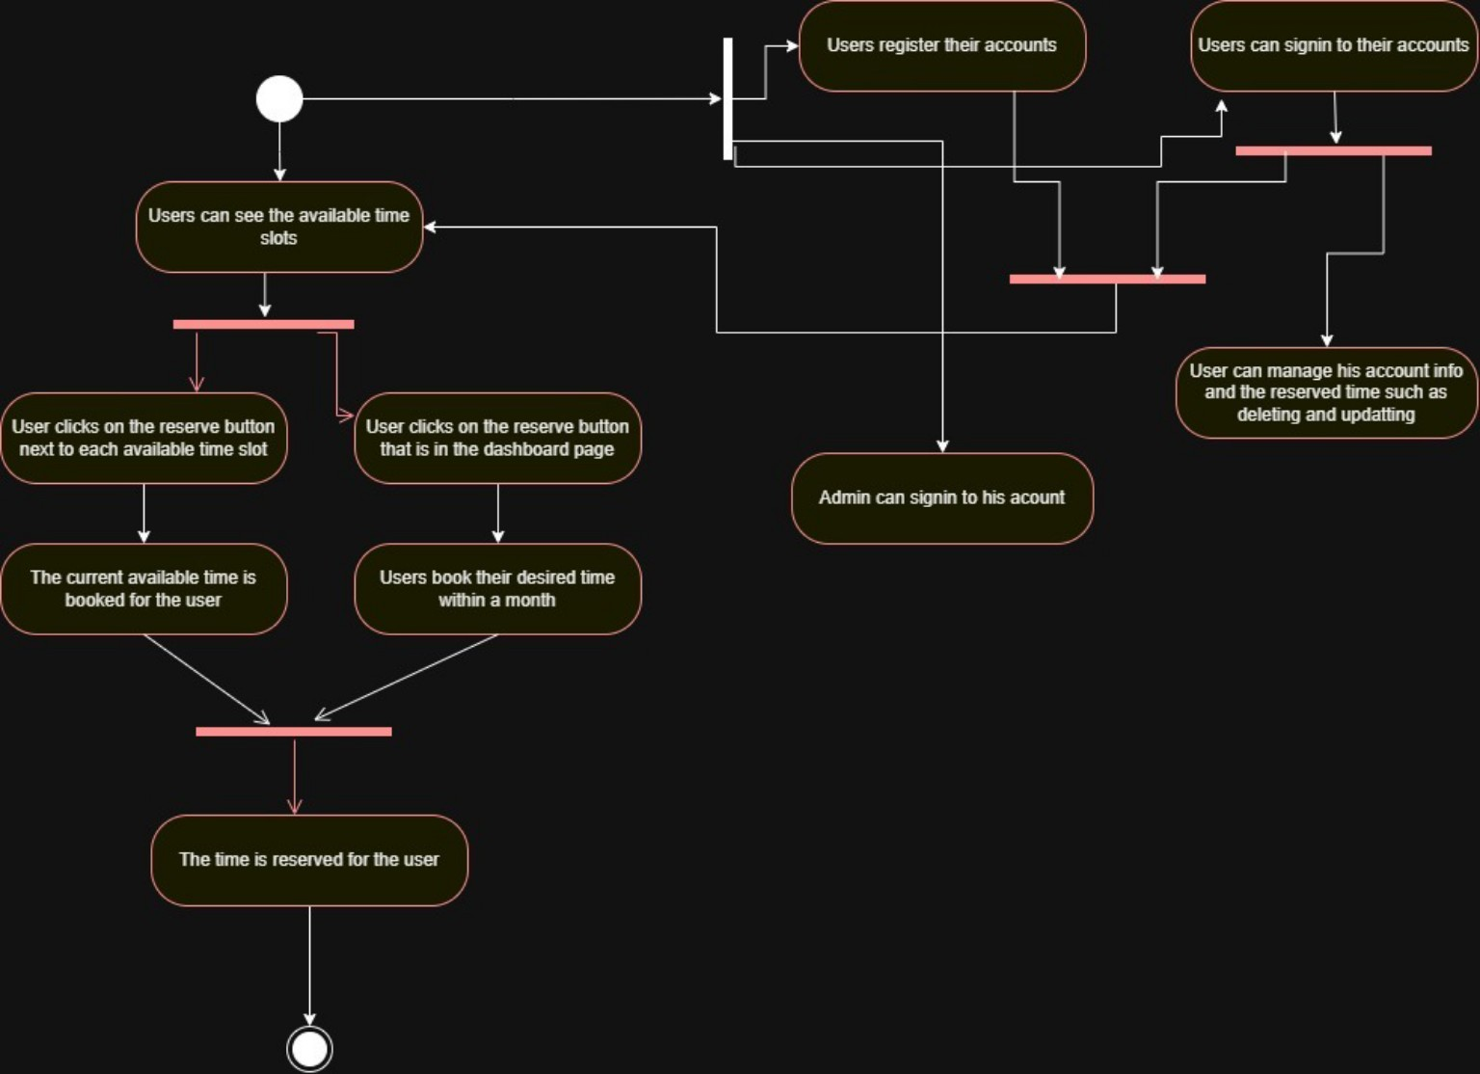
Figure 2. Activity diagram.

7.2 Reservation Workflow
- The user opens the appointment-slot page or dashboard.
- The system retrieves and displays slot availability.
- The user selects an available slot.
- The user must be signed in or logged in to book a reservation, else user can only see the dashboard and the time slots.
- The server validates authentication, slot availability, booking-window rules, notification reminder is asked from the user for every reservation, and the two-active-reservation limit.
- The application attempts to create the reservation in a transaction.
- If the slot is still available and all constraints pass, the system commits the reservation and displays confirmation.
- If another user has already reserved the slot or a rule fails, the system rejects the request and displays an appropriate message.

7.3 Cancellation Workflow
- The user requests cancellation of their own reservation, or the administrator selects a reservation to cancel.
- The application checks permissions and confirms the reservation exists and is active.
- The reservation is marked cancelled/deleted and the slot becomes available again.
- For administrator cancellation, the system attempts to email the affected user with a cancellation notice and invitation to select another slot.
- The user-facing view is refreshed to show the updated reservation and slot state.

7.4 Registration and Verification Workflow
- The user submits registration details.
- The application validates the input and creates an account in an unverified state.
- The system sends a verification email containing a link or button.
- When the user follows the verification link, the system validates the token and marks the email as verified.
- The system provides clear feedback about verification success or failure.

7.5 Reminder Workflow
- The reminder scheduler periodically checks upcoming active reservations.
- For each reservation, it calculates the reminder due time using the user's configured lead-time setting.
- If a reminder is due and has not already been sent, the system asks the email service to deliver it.
- The system records the send result to avoid duplicate reminders and support troubleshooting.
- Cancelled reservations are excluded from reminder delivery.

8. Security Design
Control | Design approach
Authentication | Require users to sign in for protected account and reservation-management actions. Protect administrator sign-in.
Authorization | Check on the server that users can modify only their own account and reservations; only the administrator can perform administrative actions.
Password storage | Store password hashes, not plaintext passwords. Use a reputable password-hashing algorithm and secure password-reset practices if password reset is implemented.
SQL injection prevention | Use parameterized queries or a trusted ORM; never concatenate untrusted input into SQL statements.
Input validation | Validate and normalize all incoming data on the server, including identifiers, dates, and form values.
Transport security | Use HTTPS with a valid TLS certificate (optional).
Session protection | Use secure session settings, regenerate session identifiers after login, and expire sessions appropriately.
Email verification tokens | Use unpredictable, time-limited, single-use verification tokens; do not expose passwords in links or emails.
Error handling | Show safe user-facing errors; do not reveal stack traces, SQL details, secrets, or internal configuration.
Secrets and logs | Keep database/email credentials out of source control. Avoid logging passwords, tokens, or unnecessary personal information.

Security controls should be tested before deployment. The SRS specifically names SQL injection prevention and HTTPS; the additional controls above are design recommendations to support the same security objective.

9. Non-Functional Design
SRS requirement | Design response | Verification approach
NFR-01: at least 1,000 concurrent users | Use efficient database queries, indexes on lookup and relationship fields, pagination where lists can grow, and capacity testing. Hosting capacity depends on the eventual deployment. | Load test with a defined workload representing 1,000 concurrent users.
NFR-02: pages within 2 seconds under agreed test conditions | Limit page payloads, optimize queries, index frequently filtered fields, and avoid synchronous work that is not needed to render the page. | Measure page response time under documented test conditions.
NFR-03: usable on low-speed internet | Use lightweight pages, compressed assets, minimal client-side dependencies, and clear loading/error feedback. | Test key workflows under a throttled low-bandwidth profile.
NFR-04: target 99% availability | Choose hosting and database services appropriate to the target; monitor service health and maintain backups and a recovery procedure. | Measure uptime over a stated observation period.
NFR-05: common attack prevention | Apply the controls in Section 8 and test validation, authentication, authorization, and SQL injection defenses. | Security tests and code review.
NFR-06: HTTPS with valid TLS | Configure HTTPS at the deployed application endpoint and redirect HTTP traffic to HTTPS where appropriate. | Verify the certificate and confirm protected pages use HTTPS.
NFR-07: simple and clear UI | Use consistent navigation, readable tables/forms, and understandable success/error states. | Usability review with representative users.

The SRS does not define detailed load-test conditions, a measurement window for 99% availability, or a numeric definition of low-speed internet. Those should be specified in the test plan without changing the stated targets.

10. Deployment Design

10.1 Logical Deployment
Deployment element | Role
User device / browser | Displays the web interface and sends HTTPS requests.
Next.js application container | Runs the Next.js application and enforces application rules.
MySQL database | Persists accounts, appointment slots, reservations, and settings.
Scheduled reminder worker | Runs periodic reminder checks as a scheduled task or worker container.
Email provider / SMTP service | Delivers verification, reminder, and cancellation messages.

10.2 Environment Configuration
- Keep development and production configuration separate.
- Store credentials and provider keys in environment configuration or a secrets manager.
- Use database backups and test restoration periodically.
- Use a supported process for applying schema changes and backing out failed deployments.
- Monitor application errors, database connectivity, reminder-job failures, and email-delivery failures.

10.3 Technology Selection
The selected technologies are Next.js and TypeScript with React.js for the web application and MySQL for the relational database. Docker will package the application and its runtime dependencies into reproducible containers, and the system will be hosted on a cloud server. The cloud provider, and email provider remain implementation choices. REST APIs are optional and should be introduced only where they provide a practical benefit.

11. Requirements Traceability
Requirement(s) | Design component(s)
FR-01 | Appointment Slot Module; Appointment slots UI; appointment data model
FR-02, FR-04 | Account and Authentication Module; Email Verification Module; registration/login UI
FR-03, FR-05 | Reservation Module; slot list and future-booking UI; reservation validation
FR-06, FR-11 | Reminder Configuration and Scheduler; reminder settings UI; see open point in Section 12
FR-07 | Administrator Module; administrator authentication and panel
FR-08 | Administrator Module; Reservation Module
FR-09 | Administrator Module; Reservation Module; Email Notification Module
FR-10 | Reservation Module; user dashboard
FR-12 | Account Module; User Dashboard
FR-13 | Reservation Module; active-reservation count and transaction-safe validation
NFR-01, NFR-02 | Application/data access design; indexes; performance and load testing
NFR-03, NFR-07 | User Interface Design; low-bandwidth and usability guidelines
NFR-04 | Deployment design; monitoring, backup, recovery planning
NFR-05, NFR-06 | Security Design; HTTPS and security verification

12. Design Decisions and Implementation Notes

12.1 Appointment Slot vs Reservation Record
The supplied ER diagram places reservation-related attributes on the appointments entity and includes an appointments attribute on user. For a relational implementation, the relationship is usually represented with foreign keys rather than a list of appointments stored as one user attribute. This SDD proposes a separate reservations table to distinguish a time slot from a user's reservation. If the project chooses a simpler schema, it must still enforce one active reservation per slot and the maximum of two active reservations per user.

12.2 Meaning of 'Two Slots at the Same Time'
FR-13 states that a user can reserve only two slots at the same time. For implementation and testing, the intended interpretation should be confirmed as a maximum of two active reservations at any given time. The design uses that interpretation provisionally because it is the clearest operational reading.

12.3 Administrator Identity and Permissions
The SRS describes one administrator that should be added to the system in the development process with the provided email and password.

12.4 Reminder Delivery Reliability
Email delivery depends on an external provider, as the SRS acknowledges. The system can record attempts and retry failures, but cannot guarantee that an external provider will deliver every message to the recipient's inbox.

12.5 Decisions Not Fixed by the SRS
- Programming language, framework, database engine, and hosting provider.
- Exact user profile fields that can be updated.
- The exact scheduling interval for reminder checks.
- The precise performance-test workload and availability measurement period.
- Whether cancelled reservations are retained as history or physically deleted; retaining a cancelled status is recommended for traceability.

Appendix A — Design Scope Statement
This document designs only the features within Zma Wār SRS Version 1.2: account registration/login, email verification, slot viewing, reservation and cancellation, user account/reservation management, administrator reservation management, reminder configuration and email notifications, the two-reservation limit, and the listed non-functional requirements. It does not introduce multi-organization SaaS, payments, SMS messaging, or unrelated features.

Appendix B — Source Artifacts
- Zma Wār Software Requirements Specification, Version 1.2, published 26 October 2026.
- Activity diagram supplied by the project author.
- ER diagram supplied by the project author.

